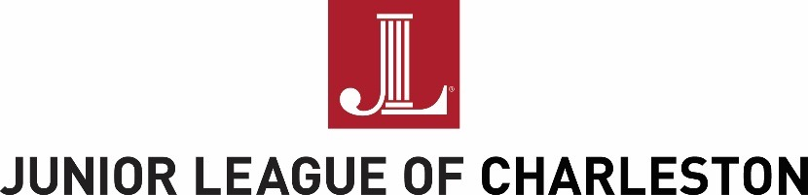
The Junior League of Charleston, Inc., is an organization of women committed to promoting voluntarism,
developing the potential of women, and improving the community through the effective action and
leadership of trained volunteers.
Done in a Day Project Proposal 2016-17
In addition to year-long community partnerships, the Junior League of Charleston offers Done in a Day (DIAD) partnerships. DIAD supports local non-profit organizations by providing volunteers on a short-term basis for a one-time event. DIAD provides the members of the Junior League of Charleston the opportunity to be involved in a variety of community projects to meet community needs with direct impact projects and allows members to use their diverse and wonderful talents to meet the immediate needs of the people of Charleston.
Projects should require 5 to 20 volunteers and 4 to 8 hours to complete. "Done-in-a-Day" project proposals may request both volunteers and funding (up to $1,000 per project) or volunteers only. A representative from your organization must be present for all projects, specifically but not limited to at all times for projects with children. Organizations may submit multiple applications.

REQUIREMENTS:
1) Requires concentrated volunteer effort of 5-20 volunteers over a 2-8 hour time period
2) The project cannot involve fundraising for the organization
3) Requests may be made for volunteers and funding or for volunteers only
4) Requests for Done-In-A-Day Projects must be received by:
- October 6, 2016 (November - January projects)
- January 17, 2017 (February - May projects)
5) One copy of the organization's 501(c)(3) letter
6) Proof of liability insurance

Proposals may be submitted:
- electronically to communityprojects@jlcharleston.org
- by fax to (843)763-1626
- or by mail to Done in a Day, Junior League of Charleston, Inc.,
51 Folly Road, Charleston, SC 29407
QUESTIONS?
Any questions about the application may be submitted to the Junior League by email to communityprojects@jlcharleston.org or by telephone to (843)763-5284.

Done in a Day Project Proposal 2016-17
Please fill in the shaded areas. This application is designed to be completed on a computer. Note that each section allows for limited characters which include spaces, punctuation and numbers, and the boxes are pre-formatted to correspond with character limits.
APPLICANT’S INFORMATION:
Name of Organization
Organization’s EIN (Non-profit ID#)
Mailing address, city, state, zip code
Physical address, city, state, zip code
President/Executive Director Name  Email; Phone | ;
Contact Person for this Project  Email; Phone | ;
PROJECT INFORMATION:
Project Title:
Project Date:
Project Start Time; End Time | ;
Location/address of the project:
Minimum # of volunteers; Maximum #: | ;
Briefly describe the project.
Scope of work to be done by volunteers:
Amount of funds requested, if applicable:
How will these funds be used?
Estimated number of people impacted by the project
I understand and agree JLC volunteers will not be asked to: handle money, fundraise, transport people or goods,
or serve alcohol.
Please remember to attach your organization’s 501(c)(3) letter and proof of liability insurance.

