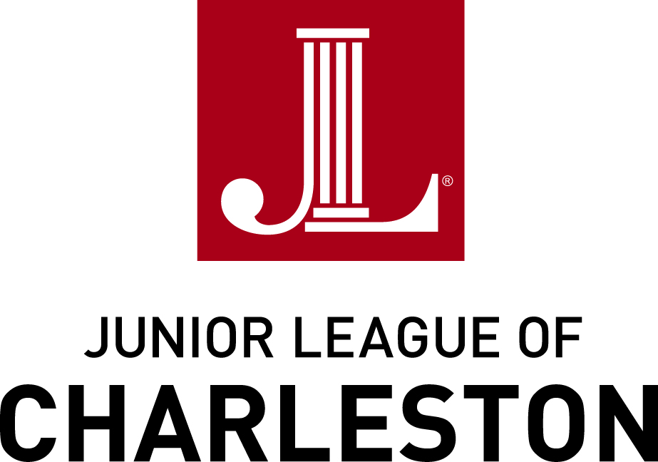
The Junior League of Charleston, Inc. is an organization of women committed to promoting voluntarism, developing the potential of women, and improving the community through the effective action and leadership of trained volunteers.
Community Project Proposal 2017-18
GENERAL INFORMATION
The Junior League of Charleston is a training organization and our mission is to build better women who build better communities. Our trained volunteers focus on combating hunger and homelessness in the Tri-County area through participation in projects with community partners, selected annually by our members through a formal proposal process. Project proposals can be made for volunteers alone or for funding and volunteers ($10,000 max). The majority of our members work outside the home, so evening and weekend volunteer opportunities are preferred.
The formal proposal process consists of a thorough review by Junior League members serving on our Community Project Development Committee. A Junior League member may contact you to discuss the proposed project in greater detail or arrange a site visit to your organization.
Completed Project Proposals are due by Friday, September 2, 2016.
Proposals may be submitted:
- electronically to communityprojects@jlcharleston.org
- by fax to (843)763-1626, or
- by mail to Community Project Development, Junior League of Charleston, Inc.,
51 Folly Road, Charleston, SC 29407

ELIGIBILITY
Applications are accepted annually from non-profits who focus on hunger and homelessness in the Tri-County area (comprised of Berkeley, Charleston, and Dorchester counties).

TIMELINE
Applications are due by Friday, September 2, 2016. Follow-up questions or visits will be arranged September 2016 through January 2017. Organizations submitting project proposals for 2017-2018 will receive written notice from the Junior League of Charleston regarding its decision on the project proposal by March 30, 2017. Selected Projects will not begin before June 1, 2017 and will end no later than May 31, 2018.

REQUIREMENTS
Applicants must provide the following completed documents:
- Application (Pages three to five below)
- Attachment #1: Copy of the organization’s most recent audited financial statement)
- Attachment #2: Thorough budget encompassing all aspects of the proposed project).
SELECTION CRITERIA
The proposed project should:
- Combat hunger and homelessness in one or more of the communities in Charleston, Berkeley or Dorchester counties.
- Identify a project goal that includes either 1) volunteer only commitment or 2) both a significant volunteer participation from League members and a monetary contribution from the JLC.
- Involve well-defined volunteer opportunities that will be performed and funded within a specific time frame, commencing no sooner than June 1, 2017, and ending no later than May 31, 2018.
- Provide for collaboration between the Junior League of Charleston, Inc., and one or more registered 501(C)(3) nonprofit organizations in good standing with the Office of the South Carolina Secretary of State.

EVALUATION
The Junior League will evaluate project proposals based on the following criteria:
- Connection of project proposal to our focus on combating hunger and homelessness in the Tri-County area.
- Inclusion of a significant volunteer component, including description of volunteer tasks and level of commitment (# hours), days and times volunteers are needed. Please note our members are available for volunteering at various times, but projects with a weekday evening or weekend day volunteer component have been historically more successful.
- Clarity of the goals and objectives of the project; including a timeline outlining tasks necessary to accomplish project goals and objectives.
- Strength of the plan for measuring the impact of the project.
- Depth of understanding about what the Junior League can bring to the project.
- Demonstrate past experience collaborating with non-profits, including the Junior League of Charleston, if applicable.
- Strength of description about how requested funding will be used to fulfill project goals and objectives. The committee will consider how funding request fits into total amount of funding available for all requests.

QUESTIONS?
Any questions about the application may be submitted to the Junior League by email to communityprojects@jlcharleston.org or by telephone to (843)763-5284.

Thank you for proposing a project that will combat hunger and homelessness in our Tri-County area.

The Junior League of Charleston, Inc., is an organization of women committed to promoting voluntarism, developing the potential of women, and improving the community through the effective action and leadership of trained volunteers.
Please fill-in the shaded areas.
This application is designed to be completed on a computer. Note that each section allows for limited charaters which include spaces, punctuation and numbers, and the boxes are pre-formatted to correspond with character limits.
APPLICANT’S INFORMATION:
Name of Organization

Parent or umbrella organization (if different from above)

First-time applicant? If so, please tell how you heard of us (50 characters)

Organization’s mission statement
(200 characters)

Year founded; year I.R.S. designation | ;
Organization’s EIN (Employer ID#)

Mailing address, city, state, zip code

Physical address, city, state, zip code

Primary telephone number

President/Executive Director

Project/program name or title for which funding is being sought

Contact Person for this project; title | ;
Contact person’s email address;  telephone number | ;

PROGRAM/PROJECT INFORMATION:
Type of Request:
- Volunteer Only | - Volunteer and Funding

Dollar amount requested | $ | Total cost of program/project, if applicable |  | $ | Annual budget of organization | $
JLC Volunteers requested |  | Total number of volunteers needed for the project |  |  | Is training required for volunteers?  (Type yes or no)
Description of proposed project to combat hunger or homelessness. Be sure to include the who, what, when, where, why and how of the request so we have a clear understanding of what grant dollars and volunteer hours would support (800 characters)
Number of hours requested and timeline for volunteer activites (please include preferred days and times available for volunteers)
Provide 1-2 program objectives/goals
(must be measurable and generally involve changes in behaviors, attitudes, conditions, knowledge or status).
Describe 1-2 activities League members would be involved in related to each objective above |  |  | 1.  2.
How will you evaluate, track or measure the degree to which you are meeting the need and objectives stated above? If your request is to continue programming already in operation, please tell how you have evaluated, tracked or measured the degree to which you have met the need stated above, and the results. (600 charaters)
Has your organization worked with the Junior League of Charleston on any other community projects? If yes, please list past project names and years.
Has your organization collaborated with other local nonprofits? If yes, please provide a brief summary of your organization’s experience as part of that collaboration(s), including how those experiences have affected your expectations for future partnerships.

What does your organization expect that the Junior League of Charleston can bring to this project?

QUESTIONS?
Any questions about the application may be submitted to the Junior League by email to communityprojects@jlcharleston.org or by telephone to (843)763-5284.

Thank you for proposing a project that will combat hunger and homelessness in our Tri-County area.

