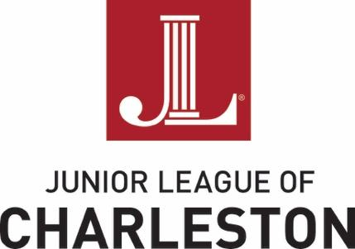
The Junior League of Charleston is an organization of women committed to promoting voluntarism, developing the potential of women, and improving the community through the effective action and leadership of trained volunteers.
Its purpose is exclusively educational and charitable.
Done in a Day Project Proposal
In addition to year-long community partnerships, the Junior League of Charleston (JLC) offers "Done-in-a-Day" (DIAD) partnerships. DIAD supports local nonprofit organizations by providing volunteers on a short-term basis for a one-time project or event. DIAD affords League members the opportunity to use their diverse talents to help elevate women and familiesin the Lowcountry through coordinated, direct impact projects.

Projects should require five to 20 volunteers over the course of two to eight hours. DIAD project proposals may request both volunteers and funding (up to $1,500 per project) or volunteers only. A representative from your organization must be present for all projects at all times, specifically, but not limited to, projects involving children. Organizations may submit multiple applications. If specific dates for a project(s) are unknown, please provide general time frame for the project (i.e. month, Spring 2021, etc.). Requests for DIAD projects should be received by October 16, 2020 with projects scheduled to occur between November 1, 2020 and May 31, 2021.

REQUIREMENTS:

- Requires concentrated volunteer effort of 5-20 volunteers over a 2-8 hour time period
- The project cannot involve fundraising for the organization
- Requests may be made for volunteers and funding or for volunteers only
- Requests for Done-In-A-Day Projects must be received by: October 16, 2020
- One copy of the organization's 501(c)(3) letter
- Proof of liability insurance

Proposals may be submitted:

- electronically to communityprojects@jlcharleston.org
- or by mail to:
Done in a Day, Junior League of Charleston, Inc.
51 Folly Road, Charleston, SC 29407

The Junior League of Charleston is an organization of women committed to promoting voluntarism, developing the potential of women, and improving the community through the effective action and leadership of trained volunteers.
Its purpose is exclusively educational and charitable.
Done in a Day Project Proposal
Please fill in the shaded areas. This application is designed to be completed on a computer. Note that each section allows for limited characters, which include spaces, punctuation and numbers, and the boxes are pre-formatted to correspond with character limits.

Applicant Information

1. Name of Organization *

2. Organization's EIN (Employer ID#)

3. Mailing Address, City, State, Zip Code *

4. Physical Address (if different from above) *

5. President/Executive Director *
First and Last name, title, email, phone

6. Primary Contact Person for the Project *
First and Last name, title, email, phone

Project Information

1. Project Title:

2. Project Date:

3. Project Start Time; End Time:

4. Location/address of the project:

5. Minimum number of volunteers; Maximum number:

6. Briefly describe the project:

7. Scope of work to be done by JLC volunteers:

8. Amount of funds requested, if applicable:

9. How will these funds be used?

10. Estimated number of people impacted by the project

I understand and agree JLC volunteers will not be asked to: handle money, fundraise, transport people or goods, or serve alcohol.

** Please remember to attach your organization’s 501(c)(3) letter and proof of liability insurance.

Questions?
Any questions about the application may be submitted to the JLC by email communityprojects@jlcharleston.org.

Thank you for your interest in becoming a partner of the Junior League of Charleston.

