51 Folly Road • Charleston, South Carolina 29407
(843) 763-5284 • Fax: (843) 763-1626
www.jlcharleston.org • Email: office@jlcharleston.org

September 21, 2015
For Immediate Release
Contact: Maggie Hill, Internal/External Communications Chair, communications@jlcharleston.org or (904)-557-8775

JUNIOR LEAGUE OF CHARLESTON TO HOST PANEL ON UNITY, INCLUSION

CHARLESTON, SC – The Junior League of Charleston, Inc. is hosting a panel discussion with women making a community change, specifically discussing unity and inclusion issues. The discussion will take place Mon. Sept. 28 at 7 pm at location the Charleston County School of the Arts auditorium in North Charleston.
After the Emanuel 9 massacre, we saw many women step forward as community leaders bridging the gap between races, and they will be part of this of this discussion.
- Dorsey Fairbairn – Founder of the “Bridge to Peace Unity Chain”. The event took place following the church shooting with more than 20,000 attendees estimated to have crossed the Ravenel Bridge in support of victims, their families, unity and love.
- Alana Simmons – Granddaughter of Emanuel 9 victim Rev. Daniel Simmons Sr. She is also the founder of the #hatewontwin movement. It is a social media movement that has spread globally, encouraging people to celebrate their similarities and spreading acts of love, instead of focusing on differences that divide people.
- Rep. Jenny Horne – SC State House representative from District 94. She made national headlines after tearfully speaking out against keeping the Confederate flag flying on the State House grounds.
Junior League member Nicole J. Shealy, a local journalist who has covered events following the deadly church shooting, will moderate the event. It will be attended by the women of the JLC and their guests.
For additional information or for an interview with League President Dorothy Thaxton, please contact Internal/External Communications Chair Maggie Hill. Contact information is above.

###

Mission and About:
The Junior League of Charleston, Inc., is an organization of women committed to promoting voluntarism, developing the potential of women, and improving the community through the effective action and leadership of trained volunteers. Its purpose is exclusively educational and charitable. The Junior League of Charleston reaches out to women of all races, religions and national origin who demonstrate an interest in and commitment to voluntarism. www.jlcharleston.org

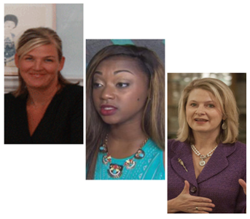
Pictured: Panel speakers Fairbairn, Simmons, and Horne.

