51 Folly Road • Charleston, South Carolina 29407
(843) 763-5284 • Fax: (843) 763-1626
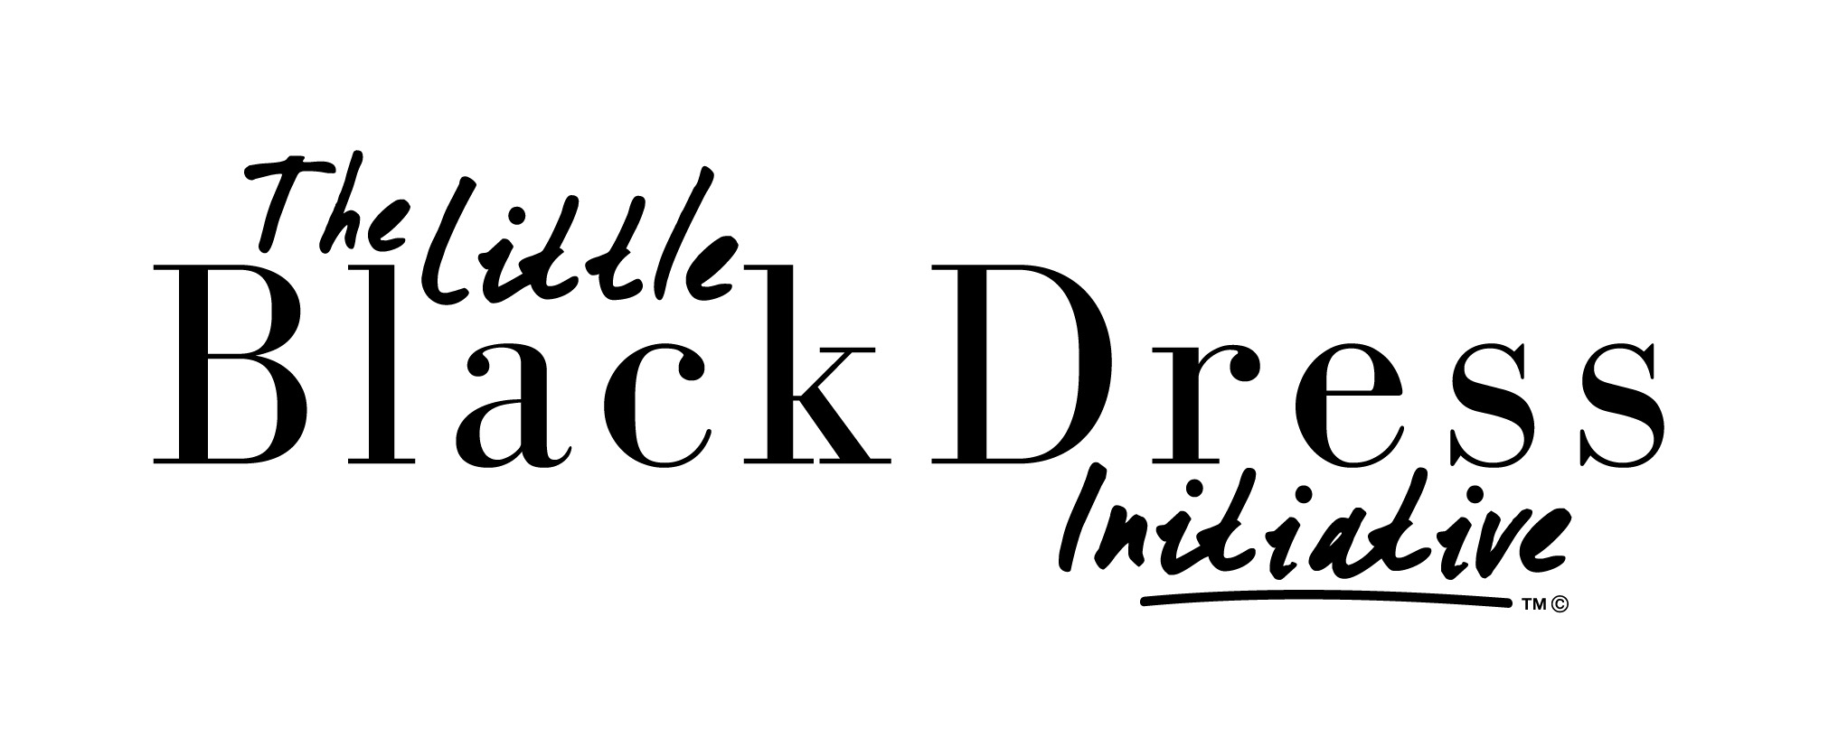
www.jlcharleston.org • Email: office@jlcharleston.org
For Immediate Release
February 25, 2016
Contact: Nicole Johnson Shealy, Asst. Director of Communications
843-327-6738, communications@jlcharleston.org

Making poverty unfashionable with inaugural Little Black Dress Initiative

CHARLESTON, SC – Women in all walks of life are no stranger to the Little Black Dress! To raise poverty awareness and raise money toward fighting hunger and homelessness in the Lowcountry, women of the Junior League of Charleston will wear the same LBD for five working days during the week of March 14-18, 2016. This social-media driven Little Black Dress Initiative will illustrate the effects poverty can have on a woman’s access to resources, confidence, and opportunities. If a participant can’t wear a black dress because it doesn't fit their work attire or lifestyle, other black clothing/accessory is acceptable during the initiative.

For this first-ever LBDI campaign in Charleston, participants from the league will get a LBDI button to wear on each of the five days and will spread the word on social media using hashtag #JLCwearsLBD. They will also share a link to gather donations. The money raised will go to our local community partners, non-profits with missions to fight hunger and homelessness in our community.

Lowcountry Poverty Statistics:

• About 1 in 5 people in Charleston County live below the national poverty level, according to census.gov. (1 in 7 for Berkeley County and 1 in 8 for Dorchester County)
• 192,500 people locally are served by Lowcountry Food Bank annually
• 55% of households served by Lowcountry Food Bank have annual incomes less than $10,000
• Women are more likely to be impoverished than men, and blacks more likely to be impoverished than other races
• 31% of black or African Americans and 12% of whites live below the poverty line in Charleston County, according to Census data (22% blacks versus 11% whites in Berkeley County and 22% blacks versus 8% whites in Dorchester County)

“We are thrilled to start this poverty awareness and fundraising campaign, LBDI, here in Charleston! It’s been a great success at other Leagues across the country and world. Our hope is to raise thousands of dollars for our local community partners to fight hunger and homelessness and in support of the Junior League of Charleston’s mission,” 2015-2016 LBDI organizer Gibbon Miler said.

A LBDI Launch Party will take place at the Belk Pop-Up Shop, March 10, from 6-9 p.m. at 473 King Street. Stay up to date on Facebook by searching Junior League of Charleston and Instagram @JLCharleston. #JLCwearsLBD

###

Mission and About:
The Junior League of Charleston, Inc., is an organization of women committed to promoting voluntarism, developing the potential of women, and improving the community through the effective action and leadership of trained volunteers. Its purpose is exclusively educational and charitable. The Junior League of Charleston reaches out to women of all races, religions and national origin who demonstrate an interest in and commitment to voluntarism. www.jlcharleston.org
